**CSE112 Artificial Intelligence**， **Week 5 2019**

Exercises and Tutorial Questions

1. **Review questions**
   1. For a general search problem, state which of iterative deepening (ID) or depth-first search (DFS) is preferred under which of the following conditions:
      1. A shallow solution is preferred. DFS
      2. The search tree may contain large or infinite branches. ID
   2. Say we define the evaluation function for a heuristic search problem as

*f* (*n*) = (1 − *w*) *g*(*n*) + *w h*(*n*)

where *g*(*n*) is the cost of the best path found from the start state to state *n*, *h*(*n*) is an admissible heuristic function that estimates the cost of a path from *n* to a goal state, and 0. 0 ≤ *w* ≤ 1. 0. What search algorithm do you get when

(i) *w* = 0. 0 uniform-cost search

1. *w* = 0. 5 A* search
2. *w* = 1. 0 greedy search
   1. Consider the following search tree, where each arc is labelled with the cost of the corresponding operator, and the leaves are labelled with the value of a heuristic function, *h*. For uninformed searches, assume children are expanded left to right. In case of ties, expand in alphabetical order.

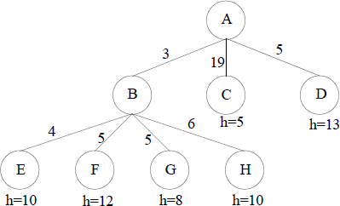

Which node will be expanded next by each following search methods?

1. Depth-First Search B
2. Greedy Best-First Search C
3. Uniform-Cost Search B
4. A* Search G

* 1. Consider the following search space where we want to find a path from the start state S to the goal state G. The table shows three different heuristic functions *h1, h2*, and *h3*.

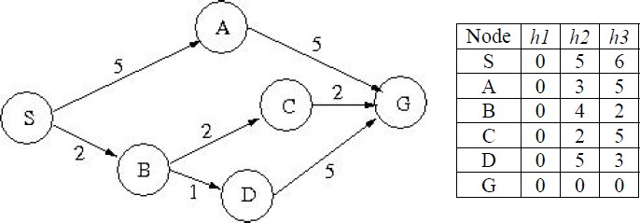

1. What solution path is found by Greedy Best-first search using *h2*? Break ties alphabetically.
2. What solution path is found by Uniform-Cost search? Break ties alphabetically.
3. Give the three solution paths found by algorithm A* using each of the three heuristic functions, respectively. Break ties alphabetically.
   1. Question on A* Heuristics

In standard A* search the objective function at each node *n* is *f*(*n*) = *g*(*n*) + *h*(*n*), where *g*(*n*) is the cost from start to this node, and *h*(*n*) is an **admissible** heuristic estimating the cost from *n* to a goal. Now let us use a different objective function:

*f*(*n*) = *w  g*(*n*) + (100 − *w*)  *h*(*n*) where 0 ≤ *w* ≤ 100.

1. What search algorithm do you get when *w* = 0?
2. What about when *w* = 50?
3. What about when *w* = 100?
   1. Consider the search graph below, where S is the start node and G1, G2, and G3 are

goal states. Arcs are labelled with the cost of traversing them and the heuristic cost to a goal is shown inside the nodes.

For each of the three search strategies below, indicate which of the goal states is reached:

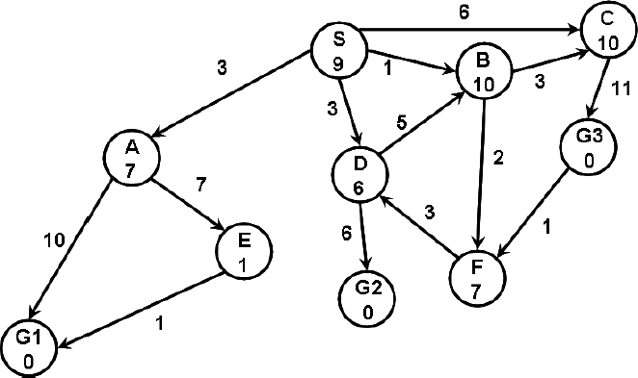

1. Breadth-first search. Goal reached:
2. Uniform cost search. Goal reached:
3. A* search. Goal reached:
   1. Consider the following path-finding problem. One can move from one small triangle to another if they share a vertex (e.g., *A* can go to *B* and *C*). However, the goal *G* can only be accessed from *F*. The number after the letter is the heuristic function value for that state. The actual cost of each move is as follows:

A move down one level (e.g. *A* →*C or B →E*) costs 1

A move sideways on the same level (e.g. *C* → *B* or *E* → *F*) costs 2 A move up one level (e.g. *B* → *A* or *C* → *A* ) costs 3

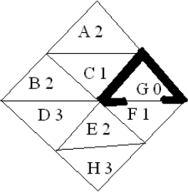

(a). Perform **Depth-First Search**, starting from *A*, using path-checking to avoid repeated states if they occur on the path back to the root in the search tree. Expand successors in alphabetical order. Show your search tree, and *circle* states that are expanded. What is the *cost* of your solution path?

(b) Perform **A* Search**, starting from *A*. Break ties alphabetically. Show the expanded states and the priority queue contents at each step. What is the cost of your solution path?

# Consider the following questions:

1. Consider the 8-puzzle in which there is a 3 x 3 board with eight tiles numbered 1 through 8. The goal is to move the tiles from a start configuration to a goal configuration, where a move consists of a horizontal or vertical move of a tile into an adjacent position where there is no tile. Each move has cost 1.
2. Is the heuristic function defined by  **admissible**, where *di* is the number of vertical plus the number of horizontal moves of tile *i* from its

current position to its goal position assuming there are no other tiles on the board, and 0 ≤ *i* ≤ 1 is a constant weight associated with tile *i*? Explain briefly why or why not.

1. Is the heuristic defined by *h*(*n*) = 8 – cost(*n*) **admissible**, where cost(*n*) is the cost from start to node *n*? Explain briefly why or why not.
2. Given two arbitrary admissible heuristics, *h1* and *h2*, which composite heuristic is better to use, max(*h1*, *h2*), (*h1* + *h2*)/2, or min(*h1*, *h2*)? Explain briefly why.

# Tutorial Questions on Knowledge Representation

**Q1. What is knowledge?**

K**nowledge = Facts ＋ Rules ＋ Control Strategy + (sometimes ) Faiths**

**Knowledge is information about some domain or subject area, or about how to do something.**

**Q2. What types of knowledge can be categorized?**

**Declarative,** **Procedural, Analogy, Generalization and Meta-level Knowledge.**

**Q3. What kind of different levels of knowledge we need to discuss in AI?**

**knowledge level, logical level and mplementation level**

**Q4. Why natural language has not been chosen to represent knowledge in the history of AI development?**

**too ambiguous for automated reasoning.**

**No clear semantics.**

**Q5. What are the desirable characteristics of an appropriate KR scheme?**

**A KR scheme must be able to actually represent the knowledge appropriate to our problem.**

**Some KR schemes are better at some sorts of knowledge than others.**

**There is no one ideal KR scheme!**

**Q6. Explain the important components of Rule-Based System**

**A collection of rules**

**A collection of facts**

**A rule fires if a fact matches the condition of the rule**

**Q7. What Is an Expert System?**

**An expert system is a computing system that is capable of expressing and reasoning about some domain of knowledge.**

**Q8. Discuss the differences between general software systems and Expert systems.**

**general software systems: Program = algorithm + data**

**Expert systems: Expert system = inference engine + knowledge base + data**

**Q9. Describe stages of the knowledge engineering process.**

**Signal -> Data -> Information -> Data**

**Q10. Open question: In your opinion, what is role of knowledge representation in AI?**

**It is a model for machines to learn human knowledge.**

**Q11. Open question: Make a general investigation about Knowledge Graph (** 知 识图谱**) and discuss its relationship with AI applications.**

**Q12. What is the meaning of meta knowledge?**

**Knowledge about what is known.**